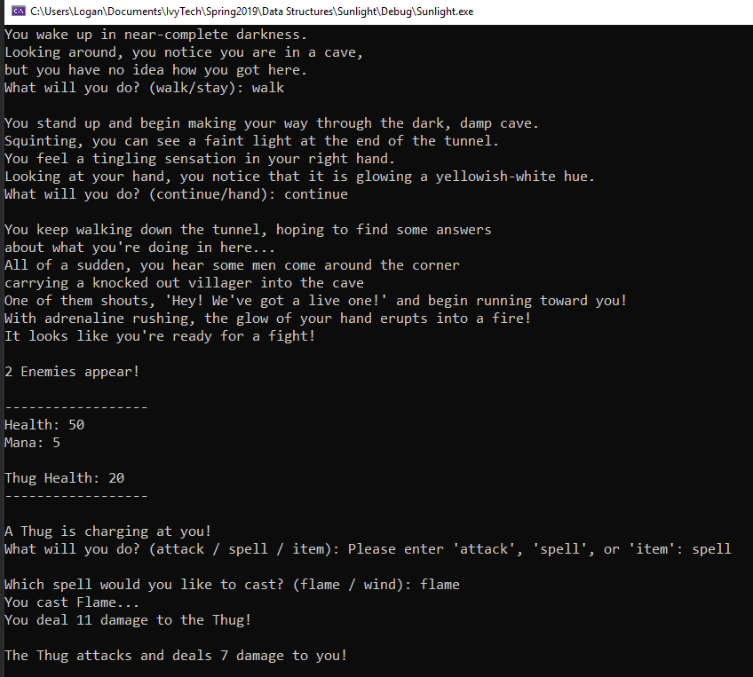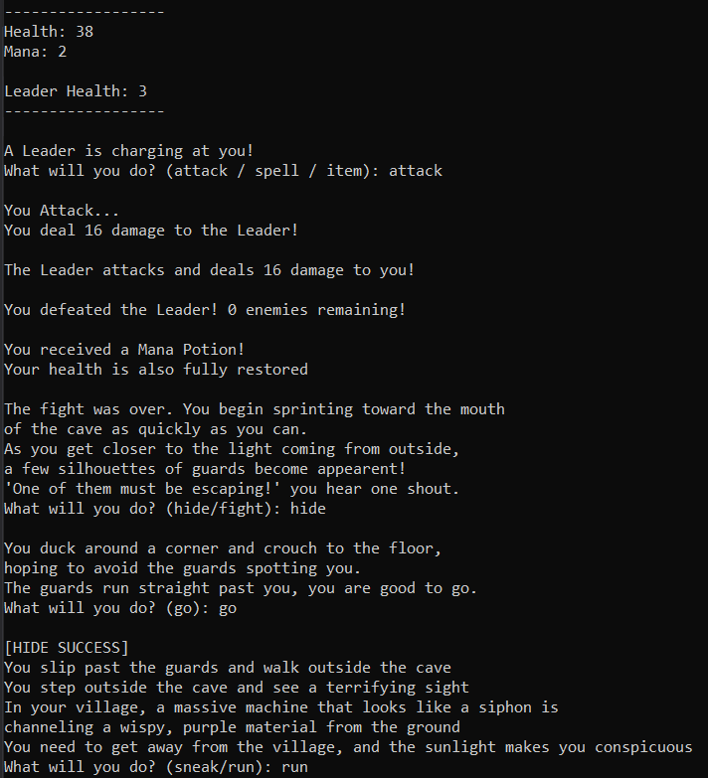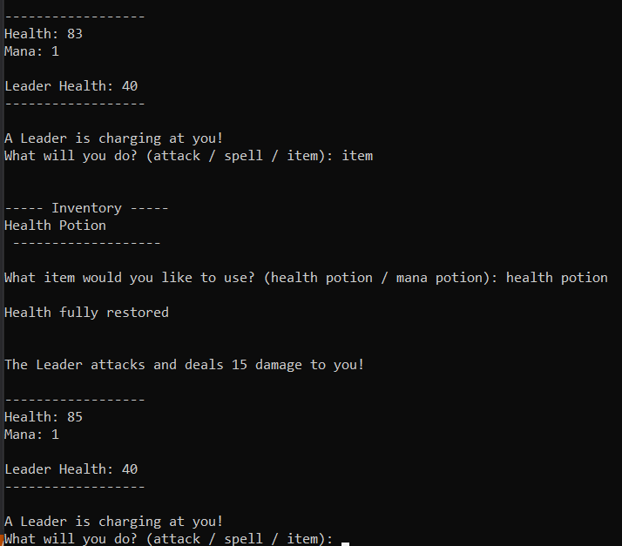
//Inventory.h
#pragma once
#include <vector>
#include <iostream>
#include <string>

class Inventory
{
private:

std::vector<std::string> inventory;

public:

void addToInventory(std::string item) //adds item to inventory
{
inventory.push_back(item);
}

void openInventory() //displays inventory to the screen
{
std::cout << "\n----- Inventory -----" << std::endl;
for (int i = 0; i < inventory.size(); i++)
{
std::cout << inventory[i] << std::endl;
}
std::cout << " -------------------\n " << std::endl;
}

int useItem(std::string item) //removes used item from inventory
{
int success;
std::vector<std::string>::iterator it = std::find(inventory.begin(), inventory.end(), item); //iterator to find item

if (it != inventory.end())
{
int indexNum = std::distance(inventory.begin(), it);
inventory.erase(inventory.begin() + indexNum);
success = 1;
}
else
{
std::cout << "Item not found in inventory" << std::endl;
success = 0;
}
return success;
}
};

//Combat.h
#pragma once
#include <iostream>
#include <string>
#include <queue>
#include <vector>
#include <time.h>
#include <Windows.h>
#include "Inventory.h"

class Combat
{
private:

Inventory myInventory; //instanciating Inventory class for use in combat

int pHealth; //player health
int pDamage; //player damage can deal
double pMana; //rechargeable stat for special skills

std::queue<int> qEnemies; //queue to control enemy flow
std::string eName; //enemy name
int eHealth; //enemy health
int eDamage; //enemy damage

std::vector<int> vEnemiesDefeated; //counts enemies defeated throughout game
std::vector<int>::iterator it; //iterates through defeated enemies list

protected:

void eThug() //standard enemy type
{
eName = "Thug";
eHealth = 20;
eDamage = 12;
}

void eLeader() //advanced enemy type
{
eName = "Leader";
eHealth = 40;
eDamage = 20;
}

public:

Combat() //constructor for Combat class to set player stats
{
pHealth = 50;
pDamage = 20;
pMana = 5;
eDamage = 0;
eHealth = 0;
}

void health() //health and mana HUD that appears every turn
{
std::cout << "\n------------------" << std::endl;
std::cout << "Health: " << pHealth << std::endl;
std::cout << "Mana: " << pMana << std::endl;
std::cout << " " << std::endl;
std::cout << eName << " Health: " << eHealth << std::endl;
std::cout << "------------------\n" << std::endl;
}

int attack() //creates player damage output
{
int roll;

srand(time(NULL)); //makes rand more random by syncing it with constantly changing clock
roll = rand() % pDamage + 1;
std::cout << "You Attack..." << std::endl;
std::cout << "You deal " << roll << " damage to the " << eName << "!" << std::endl;
eHealth = eHealth - roll; //take health away from enemy
return roll;
}

int flame() //one of user spells
{
int roll = 0;

if (pMana > 0) //check to see if user has enough mana to cast spell
{
srand(time(NULL));
roll = rand() % 40 + 1;
std::cout << "You cast Flame..." << std::endl;
pMana -= 1; //takes away a point of mana because of spell use
std::cout << "You deal " << roll << " damage to the " << eName << "!" << std::endl;
eHealth = eHealth - roll;
return roll;
}
else //if player does not have enough mana to cast spell
{
std::cout << "You don't have enough mana to cast this..." << std::endl;
return roll;
}
}

int wind() //another user spell
{
int roll = 0;

if (pMana > 0)
{
srand(time(NULL));
roll = rand() % 10 + 1;
std::cout << "You cast Wind..." << std::endl;
pMana -= 1;
std::cout << "Your blast of wind pushes the " << eName << " to the ground, staggering them!" << std::endl;
eDamage = eDamage / 2; //halves the enemy's attack damage
std::cout << "You deal " << roll << " damage to the " << eName << "!" << std::endl;
eHealth = eHealth - roll;
return roll;
}
else //if player does not have enough mana to cast spell
{
std::cout << "You don't have enough mana to cast this..." << std::endl;
return roll;
}
}

void setEnemyQueue() //sets how many enemies will appear in the fight
{
int roll;
int i;

srand(time(NULL));
roll = rand() % 3 + 1;

for (i = 0; i < roll; i++) //adding a random amount of enemies to the fight up to the roll amount
{
qEnemies.push(i);
}

if (qEnemies.size() == 1)
{
std::cout << i << " Enemy appears!" << std::endl;
}
else
{
std::cout << i << " Enemies appear!" << std::endl;
}
}

int eAttack() //enemy attack function to deal damage to player
{
int roll;

srand(time(NULL));
roll = rand() % eDamage + 1;
std::cout << "The " << eName << " attacks and deals " << roll << " damage to you!" << std::endl;
pHealth -= roll; //health subtracted from player
return roll;
}

void rewards() //post-fight rewards to player
{
srand(time(NULL));
int roll = rand() % 2 + 1; //whether the user gets a health potion or mana potion from the fight

if (roll == 1) //adds a health potion to player inventory
{
myInventory.addToInventory("Health Potion");
std::cout << "You received a Health Potion!" << std::endl;
}
else if (roll == 2) //adds a mana potion to player inventory
{
myInventory.addToInventory("Mana Potion");
std::cout << "You received a Mana Potion!" << std::endl;
}

pHealth = 100; //restores player health after each fight
std::cout << "Your health is also fully restored" << std::endl;
}

void fight() //brings in the other functions from Combat class into a collective battle function
{
std::string choice; //allows player to choose what to do during fight

setEnemyQueue();
while (qEnemies.size() > 0) //while there are still enemies
{
if (qEnemies.size() > 1)
{
eThug();
}
else
{
eLeader(); //the final enemy of fight to be leader enemy
}
while (eHealth > 0) //while current enemy alive
{
health();

std::cout << "A " << eName << " is charging at you!" << std::endl;

std::cout << "What will you do? (attack / spell / item): "; //user choice for what move to do
std::getline(std::cin, choice);
while (choice != "attack" && choice != "Attack" && choice != "ATTACK" && choice != "spell" && choice != "Spell" && choice != "SPELL" && choice != "item" && choice != "Item" && choice != "ITEM")
{
std::cout << "Please enter 'attack', 'spell', or 'item': ";
std::getline(std::cin, choice);
}
std::cout << " " << std::endl;

if (choice == "attack" || choice == "Attack" || choice == "ATTACK") //user chooses basic attack
{
attack();
}
else if (choice == "spell" || choice == "Spell" || choice == "SPELL") //user chooses spell
{
std::cout << "Which spell would you like to cast? (flame / wind): ";
std::getline(std::cin, choice);
while (choice != "flame" && choice != "Flame" && choice != "FLAME" && choice != "wind" && choice != "Wind" && choice != "WIND")
{
std::cout << "Please enter either 'flame' or 'wind': ";
std::getline(std::cin, choice);
}
if (choice == "flame" || choice == "Flame" || choice == "FLAME")
{
flame();
}
else if (choice == "wind" || choice == "Wind" || choice == "WIND")
{
wind();
}
}
else if (choice == "item" || choice == "Item" || choice == "ITEM") //user chooses to use item
{
myInventory.openInventory();

std::cout << "What item would you like to use? (health potion / mana potion): ";
std::getline(std::cin, choice);
while (choice != "health potion" && choice != "Health Potion" && choice != "Health potion" && choice != "HEALTH POTION" && choice != "mana potion" && choice != "Mana Potion" && choice != "Mana potion" && choice != "MANA POTION")
{
std::cout << "Please enter either 'health potion' or 'mana potion': ";
std::getline(std::cin, choice);
}
std::cout << " " << std::endl;
if (choice == "health potion" || choice == "Health Potion" || choice == "Health potion" || choice == "HEALTH POTION")
{
if (myInventory.useItem("Health Potion") == 1)
{
pHealth = 100;
std::cout << "Health fully restored" << std::endl;
}
}
else if (choice == "mana potion" || choice == "Mana Potion" || choice == "Mana potion" || choice == "MANA POTION")
{
if (myInventory.useItem("Mana Potion") == 1)
{
pMana = 5;
std::cout << "Mana fully restored" << std::endl;
}
}
std::cout << " " << std::endl;
}
std::cout << " " << std::endl;

eAttack();

if (pHealth <= 0)
{
std::cout << "You died..." << std::endl;
std::cout << "But I'll give you another chance" << std::endl;
pHealth = 50;
}

if (eHealth <= 0) //if enemy dies
{
qEnemies.pop(); //take an enemy out of the queue
vEnemiesDefeated.push_back(1); //adds an enemy to the 'vEnemiesDefeated' vector
std::cout << "\nYou defeated the " << eName << "! " << qEnemies.size() << " enemies remaining!\n" << std::endl;
}
}
}

rewards();
std::cout << " " << std::endl;

}

void enemiesDefeated() //shows how many enemies defeated in playthrough
{
int total = 0;

for (it = vEnemiesDefeated.begin(); it != vEnemiesDefeated.end(); ++it) //iterates through the vector and adds the total together
{
total += *it;
}

std::cout << "Congratulations!" << std::endl;
std::cout << "Throughout your adventure, you defeated " << total << " enemies!" << std::endl;
}

};

//Diffusion.h
#pragma once
#include <time.h>

class Diffusion //ways to avoid combat
{
private:

int roll = 0;

public:

int dSneak() //roll for sneaking around enemies
{
srand(time(NULL));
roll = rand() % 25 + 1;
return roll;
}

int dLie() //roll for lying way out of fight
{
srand(time(NULL));
roll = rand() % 10 + 1; //not a great liar...
return roll;
}

int dHide() //roll for hiding from enemies
{
srand(time(NULL));
roll = rand() % 30 + 1;
return roll;
}
};

//Source.cpp
/*
* Program Name: Final Application
* Author: Logan Kinman
* Date Last Updated: 5-9-2019
* Purpose: Create a turn-based fighter/adventure game using multiple data structures
*/

#pragma once;
#include <iostream>
#include <string>
#include "Inventory.h"
#include "Combat.h"
#include "Diffusion.h"

int main()
{
std::string userChoice; //used for branching paths in game

Combat myCombat; //instanciate Combat class
Diffusion myDiffusion; //instanciate Diffusion class

std::cout << "You wake up in near-complete darkness.\nLooking around, you notice you are in a cave, \nbut you have no idea how you got here." << std::endl;
std::cout << "What will you do? (walk/stay): ";
std::cin >> userChoice;
while (userChoice != "walk" && userChoice != "WALK" && userChoice != "stay" && userChoice != "STAY")
{
std::cout << "Enter either 'walk' or 'stay': ";
std::cin >> userChoice;
}
std::cout << " " << std::endl;

if (userChoice == "walk" || userChoice == "WALK")
{
std::cout << "You stand up and begin making your way through the dark, damp cave.\nSquinting, you can see a faint light at the end of the tunnel." << std::endl;
std::cout << "You feel a tingling sensation in your right hand.\nLooking at your hand, you notice that it is glowing a yellowish-white hue." << std::endl;
std::cout << "What will you do? (continue/hand): ";
std::cin >> userChoice;
while (userChoice != "continue" && userChoice != "CONTINUE" && userChoice != "hand" && userChoice != "HAND")
{
std::cout << "Enter either 'continue' or 'hand': ";
std::cin >> userChoice;
}
std::cout << " " << std::endl;
if (userChoice == "continue" || userChoice == "CONTINUE")
{
std::cout << "You keep walking down the tunnel, hoping to find some answers\nabout what you're doing in here..." << std::endl;
}
else
{
std::cout << "Your hand has never done anything like this before...\nWhat could be going on with you, and why are you in this cave?" << std::endl;
}
std::cout << "All of a sudden, you hear some men come around the corner\ncarrying a knocked out villager into the cave" << std::endl;
std::cout << "One of them shouts, 'Hey! We've got a live one!' and begin running toward you!" << std::endl;
std::cout << "With adrenaline rushing, the glow of your hand erupts into a fire!\nIt looks like you're ready for a fight!\n" << std::endl;

myCombat.fight();
}
else
{
std::cout << "You lay in the damp muck of the cave,\nwith unanswered questions running through your mind about\nhow you got here." << std::endl;
std::cout << "All of a sudden, you hear some men come around the corner\ncarrying a knocked out villager into the cave" << std::endl;
std::cout << "One of them shouts, 'Hey! We've got a live one!' and begin running toward you!" << std::endl;
std::cout << "With adrenaline rushing, your hand begins to glow and erupts into a fire!\nIt looks like you're ready for a fight!\n" << std::endl;

myCombat.fight();
}

std::cout << "The fight was over. You begin sprinting toward the mouth\nof the cave as quickly as you can." << std::endl;
std::cout << "As you get closer to the light coming from outside,\na few silhouettes of guards become appearent!" << std::endl;
std::cout << "'One of them must be escaping!' you hear one shout." << std::endl;
std::cout << "What will you do? (hide/fight): ";
std::cin >> userChoice;
while (userChoice != "hide" && userChoice != "HIDE" && userChoice != "fight" && userChoice != "FIGHT")
{
std::cout << "Enter either 'hide' or 'fight': ";
std::cin >> userChoice;
}
std::cout << " " << std::endl;

if (userChoice == "hide" || userChoice == "HIDE")
{
std::cout << "You duck around a corner and crouch to the floor,\nhoping to avoid the guards spotting you." << std::endl;
std::cout << "The guards run straight past you, you are good to go." << std::endl;
std::cout << "What will you do? (go): ";
std::cin >> userChoice;
while (userChoice != "go" && userChoice != "GO")
{
std::cout << "Enter 'go': ";
std::cin >> userChoice;
}
std::cout << " " << std::endl;

if (myDiffusion.dHide() > 5)
{
std::cout << "[HIDE SUCCESS]" << std::endl;
std::cout << "You slip past the guards and walk outside the cave" << std::endl;
}
else
{
std::cout << "[HIDE FAIL]" << std::endl;
std::cout << "As you begin walking out of the cave a guard grabs you\nby the shoulders and whips you around" << std::endl;
std::cout << "'Not so fast!' he cries, as he raises his hand to attack!" << std::endl;
myCombat.fight();
}
}
else
{
myCombat.fight();
}

std::cout << "You step outside the cave and see a terrifying sight" << std::endl;
std::cout << "In your village, a massive machine that looks like a siphon is\nchanneling a wispy, purple material from the ground" << std::endl;
std::cout << "You need to get away from the village, and the sunlight makes you conspicuous" << std::endl;
std::cout << "What will you do? (sneak/run): ";
std::cin >> userChoice;
while (userChoice != "sneak" && userChoice != "SNEAK" && userChoice != "run" && userChoice != "RUN")
{
std::cout << "Enter either 'sneak' or 'run': ";
std::cin >> userChoice;
}
std::cout << " " << std::endl;

if (userChoice == "sneak" || userChoice == "SNEAK")
{
if (myDiffusion.dSneak() > 15)
{
std::cout << "[SNEAK SUCCESS]" << std::endl;
std::cout << "You make it to the edge of the village" << std::endl;
}
else
{
std::cout << "[SNEAK FAIL]" << std::endl;
std::cout << "Some guards see you trying to sneak your way\nthrough the village in broad daylight" << std::endl;
std::cout << "You begin to run as quickly as you can!" << std::endl;
std::cout << "Eventually, you make it to the edge of the village" << std::endl;
}
}
else
{
std::cout << "You decide to make a run for it. You sprint as quickly\nas you can through the village." << std::endl;
std::cout << "You make it to the edge of the village" << std::endl;
}
std::cout << "and dash into a thicket of trees." << std::endl;

std::cout << "Your arm begins to burn and cause extreme pain! What is going on!?" << std::endl;
std::cout << "All of a sudden, and hand grabs and covers your mouth\nand sternly whispers to you not to move and to stay quiet!" << std::endl;
std::cout << "What will you do? (struggle/quiet): ";
std::cin >> userChoice;
while (userChoice != "struggle" && userChoice != "STRUGGLE" && userChoice != "quiet" && userChoice != "QUIET")
{
std::cout << "Enter either 'struggle' or 'quiet': ";
std::cin >> userChoice;
}
std::cout << " " << std::endl;

if (userChoice == "struggle" || userChoice == "STRUGGLE")
{
std::cout << "You try to struggle against the unknown attacker,\nbut it's no use." << std::endl;
std::cout << "'I told you not to move!' they state again" << std::endl;
}
std::cout << "'Don't worry.' they say, loosening their grip, 'I'm not your enemy.'" << std::endl;
std::cout << "But if I hadn't have grabbed you, you would've tried to attack me.\n" << std::endl;
std::cout << "You look at the stranger and notice he is a man with long,\nblack hair and a white countenance" << std::endl;
std::cout << "What will you do? (speak/quiet): ";
std::cin >> userChoice;
while (userChoice != "speak" && userChoice != "SPEAK" && userChoice != "quiet" && userChoice != "QUIET")
{
std::cout << "Enter either 'speak' or 'quiet': ";
std::cin >> userChoice;
}
std::cout << " " << std::endl;

if (userChoice == "speak" || userChoice == "SPEAK")
{
std::cout << "'Yeah,' you say, 'well I've done enough fighting today.'" << std::endl;
std::cout << "'I just want to know what's going on here?'" << std::endl;
}
else
{
std::cout << "'Not going to talk, I see.' he says, 'I'm..I'm sorry.\nI just couldn't take any chances.'" << std::endl;
}

std::cout << "'They are siphoning the magic from this village, he explains,\n'And with the magic, they plan on taking rule over the whole land.'" << std::endl;
std::cout << "'But I know how to stop them' he continues,\n'If the siphon's core is destroyed, their whole plan is destroyed.'" << std::endl;

std::cout << "What will you do? (go): ";
std::cin >> userChoice;
while (userChoice != "go" && userChoice != "GO")
{
std::cout << "Enter either 'go' or 'GO': ";
std::cin >> userChoice;
}
std::cout << " " << std::endl;

std::cout << "You make your way toward the siphon. It is large and\nvery loud, concealing your presence." << std::endl;
std::cout << "You creep around the machine until you find\nwhat looks like a control panel." << std::endl;
std::cout << "As you are fiddling with the control panel,\nsome guards walk up and ask you to state your business" << std::endl;
std::cout << "What will you do? (lie/fight): ";
std::cin >> userChoice;
while (userChoice != "lie" && userChoice != "LIE" && userChoice != "fight" && userChoice != "FIGHT")
{
std::cout << "Enter either 'lie' or 'fight': ";
std::cin >> userChoice;
}
std::cout << " " << std::endl;

if (userChoice == "lie" || userChoice == "LIE")
{
if (myDiffusion.dLie() > 5)
{
std::cout << "[LIE SUCCESS]" << std::endl;
std::cout << "'Can't you see I'm trying to fix this thing?' you shout" << std::endl;
std::cout << "'Or I can just stop and let boss be mad at you folk!'" << std::endl;
std::cout << "'Er..no, please continue' the guards answer\n'Keep up the, uh, good work.'" << std::endl;
}
else
{
std::cout << "[LIE FAIL]" << std::endl;
std::cout << "You try to make up some story about being a\ntechnician fixing the siphon." << std::endl;
std::cout << "The looks on the guards faces show you they are not convinced..." << std::endl;
myCombat.fight();
}
}
else
{
myCombat.fight();
}

std::cout << " " << std::endl;
std::cout << "As you mess with the control panel some more,\nyou manage to pop it off the siphon entirely!" << std::endl;
std::cout << "You see what seems to be the exposed core -\na bright white ball of pure energy." << std::endl;
std::cout << "\nSuddenly, your arm begins to burn with a pain you have\nnever felt before!!!" << std::endl;
std::cout << "All you have to do is grab the core." << std::endl;
std::cout << "What will you do? (grab/run): ";
std::cin >> userChoice;
while (userChoice != "grab" && userChoice != "GRAB" && userChoice != "run" && userChoice != "RUN")
{
std::cout << "Enter either 'grab' or 'run': ";
std::cin >> userChoice;
}
std::cout << " " << std::endl;

if (userChoice == "run" || userChoice == "RUN")
{
while (userChoice != "grab" || userChoice == "GRAB")
{
std::cout << "All you have to do is grab the core: ";
std::cin >> userChoice;
}
}

std::cout << "\nYou reach inside the siphon, slowly getting closer to the core." << std::endl;
std::cout << "Inches away, your hand is burning more and more" << std::endl;
std::cout << "You grab the core." << std::endl;
std::cout << "The light around you starts to become brighter\nand brighter until\n.\n.\n.\n.\n.\n." << std::endl;
std::cout << "Until there is nothing\n.\n.\n.\n.\n.\n." << std::endl;
std::cout << "The end" << std::endl;

myCombat.enemiesDefeated();

system("pause");
return 0;
}

